s
D424 – Software Engineering
Task 3
Capstone Proposal Project Name: |   Legends of the Lance
Student Name: | Joseph “Joey” Guynes

Legends of the Lance Design Document 3
Class Design 3
UI Design 5
Unit Test Plan 6
Introduction 6
Purpose 6
Overview 7
Test Plan 7
Items 7
Features 7
Deliverables 7
Tasks 7
Needs 7
Pass/Fail Criteria 7
Specifications 8
Procedures 8
Results 9
Introduction 9
Installation and Using the Application 9
Reports 12

Legends of the Lance Design Document

Class Design
Below you will find the Schema for the database. This will include the basic layout with dependencies on all the database tables and their data type. Followed by DMGLs showing the class representation of the internal classes. We can then break the DMGL down to a UML view and see the individual aspects of the classes.
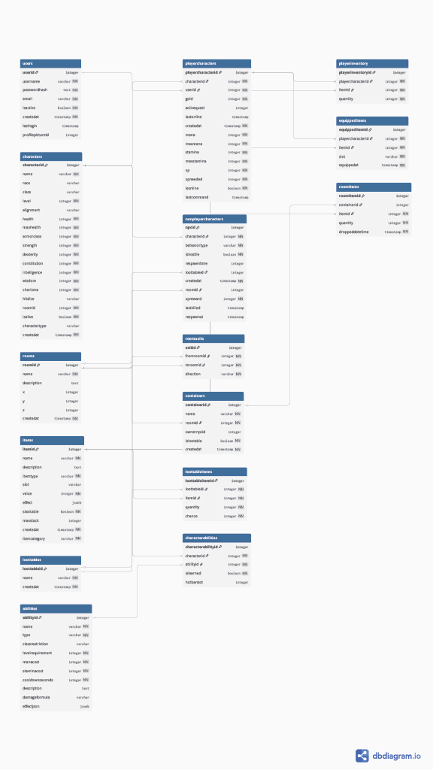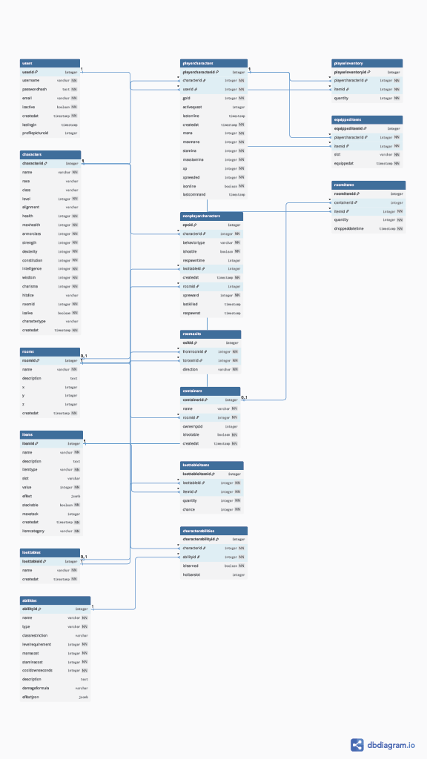
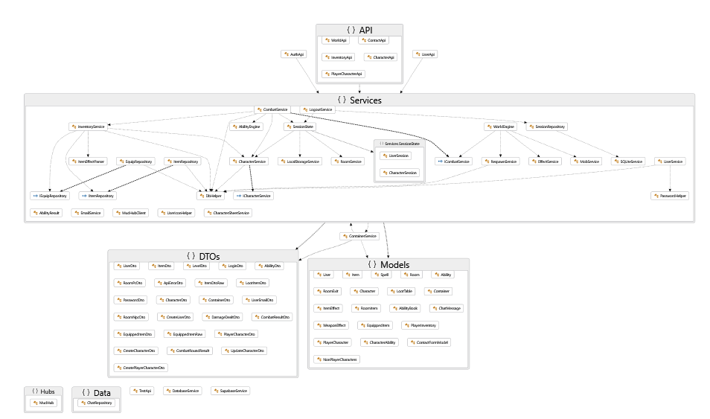
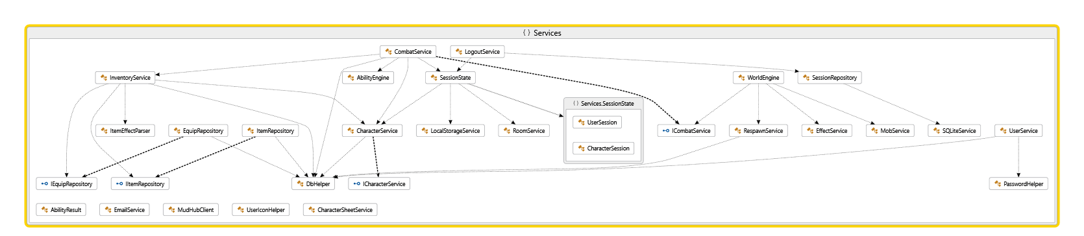
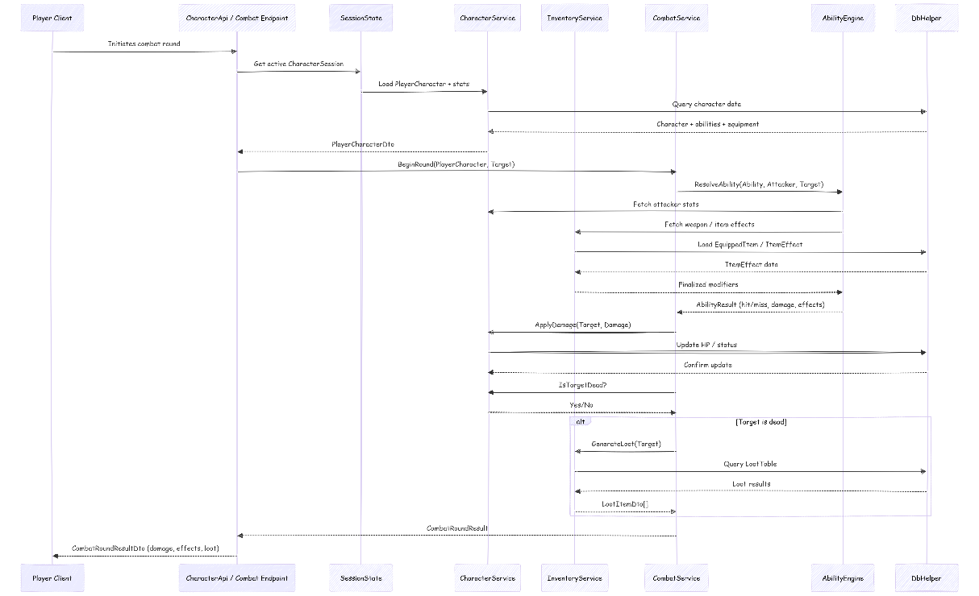
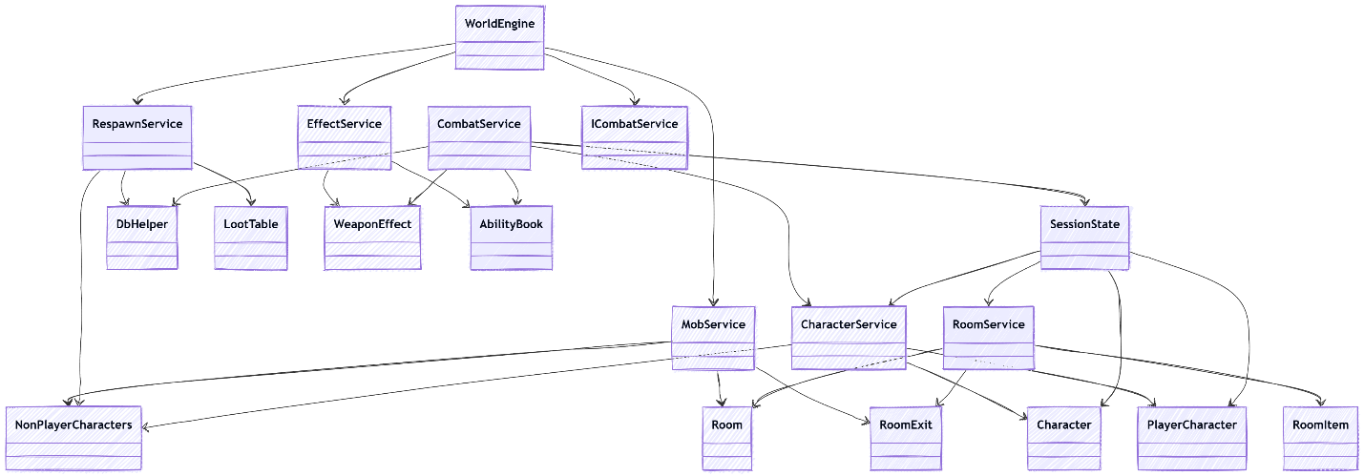

UI Design
The UI Design is focused on a retro aesthetic with a modern twist. It will use a compass rose on the left and command buttons that are unique for the user experience.
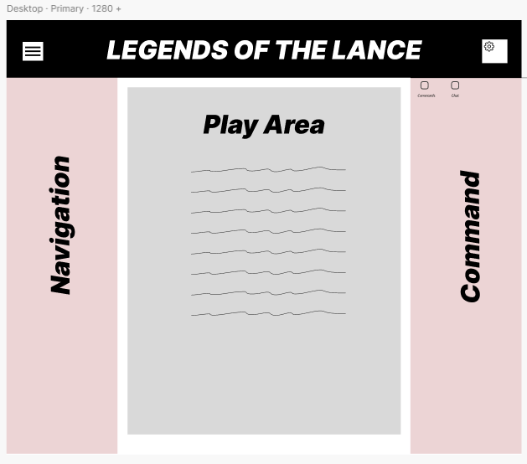
Figure 1: Low Fidelity Of Combat

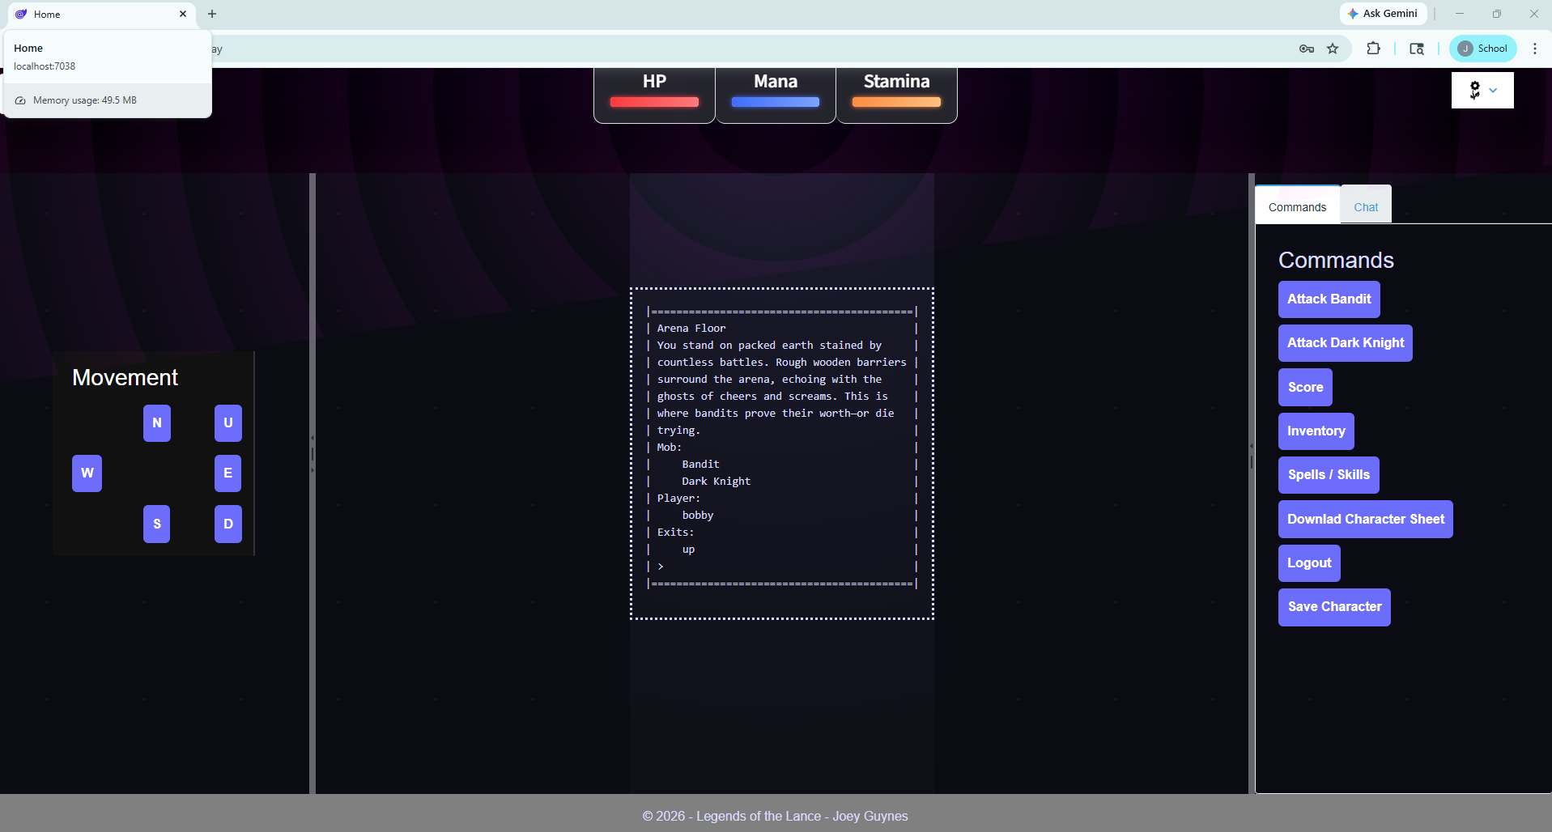
Figure 2: Screenshot of live site

Unit Test Plan

Introduction

Purpose
The primary testing that was conducted was manual testing after each change incremental change. This allowed the team to ensure that the functionality of each step hadn’t altered the abilities that were already working. After completion of the main engine and all Database connections were established, an xUnit test was conducted.

Overview
The first set of tests that were complete were cosmetics in nature as they were ensuring that the homepage would load and we could successfully navigate through the pages and have interactive server capabilities on each page that needed it.

Test Plan

Items
- Visual Studio
- Modern Browser

Features
- Navigation
- Interactivity

Deliverables
- Visual Deliverable

Tasks
- Run the application to allow the server to boot.
- Navigate to the local server.
- Use the Navigation sidebar to navigate through the site.

Needs
The only things that needed to be running for this test will be the server itself and the browser for connectivity.

Pass/Fail Criteria
Pass: For a pass each HREF should navigate to the appropriate page, and the buttons should, when clicked, enact their actions.
Fail: A failure would entail non navigation, or non-button activity.

Specifications
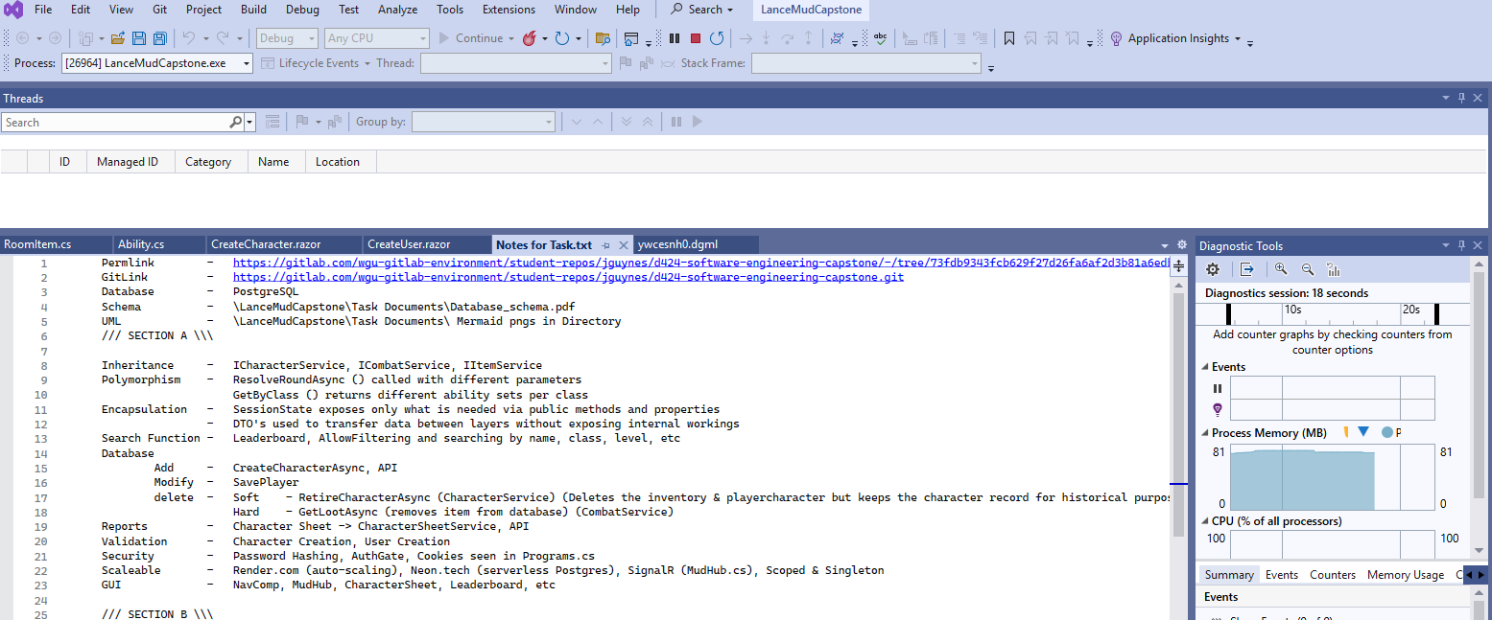

Procedures
When testing the navigation we navigated to each page on the navigation panel. It was found that all HTML markup worked efficiently.
The next step was to test any buttons.

Results
Using a console log, it was found that the button clicks were not triggering to the server side. It was then deduced that the Interactive Server was not present on the create user page. It was then determined that the Layout Pages needed to house the interactive server.

Guide for Setting Up and Maintaining App
. User Guide

Introduction
To play Legends of the Lance, all you will need is a modern browser as the functionality will reside inside the browser.

Installation and Using the Application
- Choose the modern browser of your choice, we recommend Google Chrome.
  - https://www.google.com/chrome/browser-tools/
- Navigate to the Legends of the Lance Home Page.
  - https://jguynes-capstone.onrender.com
- If you do not have an account, you will need to create a new account at this time.
  - 
  - 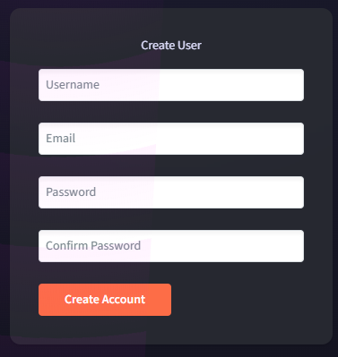
- If you already have an account, you can navigate to the Login page instead.
  - 
  - 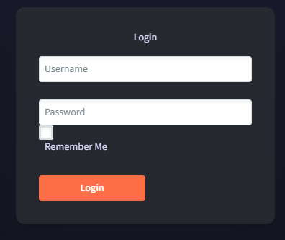
  - For your convenience you can utilize the Remember Me Check Box for easier login.
- Once Logged in you will either select a character you have created or create a new character.
  - 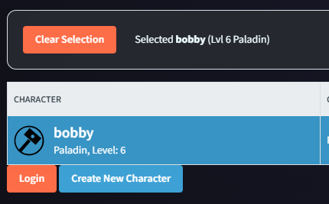
- There is a side bar expander that will allow you to see the command panel as well as the navigation panel. These are what allow you interact with the world around you.
- 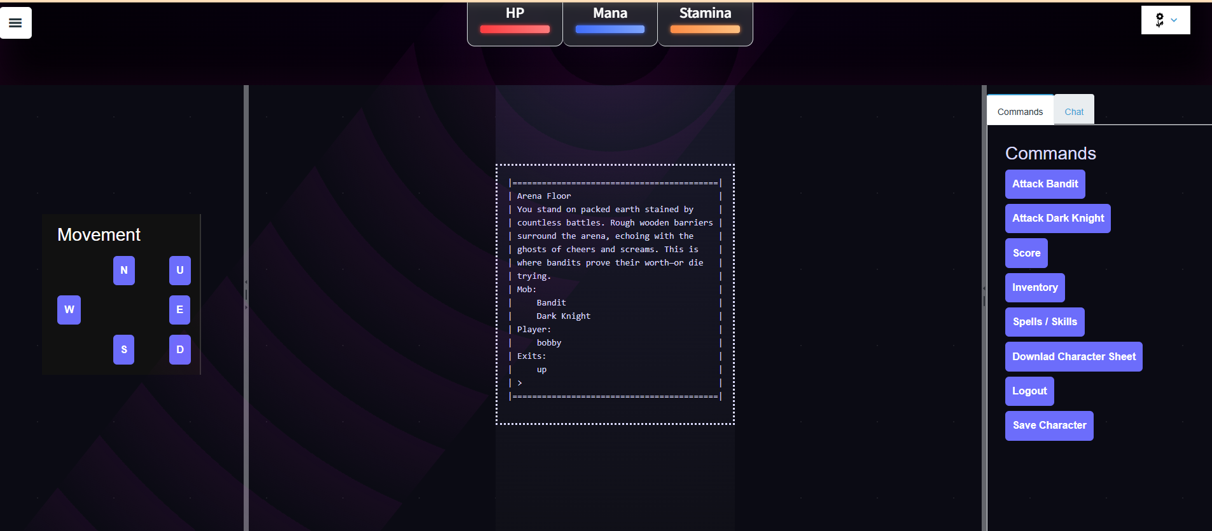
- On the command panel you will see an option to Download Character Sheet, this will allow you to take your character with you to a tabletop Dungeons and Dragons game.
  - As the equipment in Legends of the Lance does not translate to standard Dungeons and Dragons, you will find equipment and inventory to be blank and ready to be filled in.
- The last step is having fun.

Reports
- If you would like to have a character sheet, you can click on Download Character Sheet.
  - 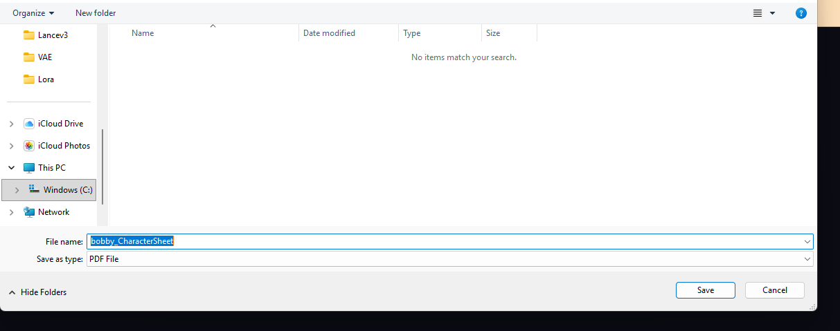
  - A save dialog will open.
- 